catalogue

Introduction 2

background 2

Significance 2

Business problem identification 3

Business problems or challenges: 3

Potential role of information systems in addressing these issues: 4

Analyze 5

Blockchain 5

Cloud Computing 7

Big data 8

Initialize the project management plan 10

Conclusion 12

Reference 14

# Introduction

## background

The Roads and Maritime Authority of New South Wales (RMS) is the New South Wales Government agency responsible for building and maintaining road infrastructure and managing the day-to-day compliance and safety of roads and waterways. It provides basic travel advice, customer registration and public transport reporting systems for New South Wales. It is one of the most used websites for households in New South Wales.

RMS consists of two business projects, namely the RMS website and the Service NSW mobile application. However, the Service NSW mobile app has many other business functions that do not cover all the functions of the RMS website. This, in turn, creates a lot of confusion for current customers. This also increases the difficulty of synchronizing databases and conducting further research on data analysis and data visualization.

## Significance

This research is important because Roads and Maritime NSW (RMS) plays a key role in infrastructure and public transport management in the region. The services provided by RMS are vital for residents and businesses in New South Wales. However, differences and inconsistencies between the RMS website and the Service NSW mobile app can lead to user confusion, data synchronization issues, and difficulties in data analysis and visualization. Therefore, the importance of research is to improve the efficiency, user experience and data management of RMS to better meet the needs of the public and government.

# Business problem identification

## Business problems or challenges:

Functional fragmentation: RMS's business covers road infrastructure construction, maintenance, traffic compliance management, and waterway safety. However, there is functional fragmentation between the RMS website and the Service NSW mobile app, and their business functions are not fully integrated, which leads to confusion among users in finding relevant information and performing tasks, and uncoordinated business operations.

Data synchronization and consistency issues: RMS needs to maintain a large amount of data, including traffic flow, construction projects, vehicle registration information and so on. Data synchronization and consistency is complicated by the decentralized nature between the RMS website and the Service NSW mobile app. This can lead to data inconsistencies, which can confuse decision making and data analysis.

User experience issues: User experience is critical to the success of RMS. However, due to inconsistent business functions and interfaces, users may face confusion and dissatisfaction. This may reduce user satisfaction and affect their use of the services provided by RMS.

## Potential role of information systems in addressing these issues:

Integration and integration: Information systems can be used to integrate the business functions of an RMS, making it more integrated and less fragmented. With a consistent platform, users can more easily access a variety of services and information.

Data management and synchronization: Information systems can be used for data management, including maintenance of data synchronization and consistency. It automates data updates and synchronization, ensuring data accuracy and consistency, thereby reducing errors and improving decision quality.

User experience Improvement: Information systems can improve the user experience by providing a consistent user interface and process. It will be easier for users to understand and use the services provided by RMS, improving user satisfaction.

# Analyze

## Blockchain

|  |  |  |  |
| --- | --- | --- | --- |
| technology | feasibility | consistency | technological review |
| Blockchain is a distributed ledger technology that ensures the security and transparency of data.1 | Blockchain can improve data consistency because all transactions are recorded in a distributed ledger that cannot be tampered with.2 | The technical requirements and costs of blockchain need to be evaluated to determine its feasibility. | Blockchain can be used to manage vehicle registration and traffic infringement data, ensuring the security and consistency of data. However, there is a need to invest in blockchain infrastructure. |

The application of a given case study and its advantages and limitations:

Firstly, blockchain technology can be used to ensure data reliability between the RMS website and the Service NSW mobile app. Each data update is added to the blockchain in the form of a block, ensuring real-time management of the data. This helps solve the confusion problem.

Moreover, blockchain provides a high degree of data security because data is almost impossible to damage with once it is added to the blockchain. This is essential for the security of compliance data on roads and waterways.

Finally, the blockchain records the details of each data transaction, making the origin and changes of the data traceable. This helps manage data transparency and trust.

Positive:

Data security: Blockchain provides a high degree of data security, reducing the risk of data tampering or unauthorized access.

Data consistency: Blockchain ensures data reliability between different systems and solves the problem of confusion.

negative:

Energy consumption: Some blockchains require an amount of computing power and result in high energy consumption.

Legal and compliance: In some regions, blockchain technology may involve legal and compliance issues, particularly with regard to personal data and privacy.

## Cloud Computing

|  |  |  |  |
| --- | --- | --- | --- |
| technology | feasibility | consistency | technological review |
| Cloud computing provides flexible data storage and computing resources with high feasibility.3 | Cloud computing platforms ensure data consistency because data is stored in the cloud and accessible across multiple devices.4 | Evaluate the quality of service and security of cloud computing providers. | Provide a reliable space and powerful access interface to not only analyze large amounts of data, but also store, manage, and determine data using a relational DBMS architecture. |

The application of a given case study and its advantages and limitations:

Applications: Migrating RMS(the case: “Roads and Maritime NSW” (RMS)) data and functionality to the cloud solves database synchronization issues while providing flexibility. Cloud computing can be used to host RMS websites and Service NSW mobile applications, ensuring high availability of the system.

Advantages:

Flexibility: Cloud computing allows computing resources to be allocated on demand to accommodate traffic peaks and troughs.

Data synchronization: Cloud platforms can ensure real-time synchronization of databases and reduce confusion.

Data Analysis and visualization: Cloud computing provides powerful data analysis and visualization tools to help better understand customer needs and data trends.

Disadvantages:

Security: Cloud computing requires appropriate security measures to protect data in order to prevent data breaches or unauthorized access.

## Big data

|  |  |  |  |  |
| --- | --- | --- | --- | --- |
| technology | feasibility | consistency | technological review | case project management |
| Big data technology is used to process large-scale data and high-dimensional data and capture the data in real time, quickly and effectively.5 | Big data analytics is the examination of large amounts of data to find hidden patterns. 6 | The cost and complexity of big data tools and technologies need to be assessed. | Used to analyze traffic flow, road conditions and user demand data |  |

The application of case studies and their advantages and limitations:

Big data technology can be used to analyze data from RMS websites and Service NSW mobile apps. Through analyzing the data, RMS can better understand customer needs, road usage trends and compliance issues to improve service.

Advantages:

Data visualization: Data visualization tools provide a more intuitive way to present data and make decision making easier.

Real-time: Big data technology supports real-time data analysis, enabling RMS to take action quickly.

Disadvantages:

Privacy issues: When processing big data, it is necessary to comply with relevant privacy regulations to ensure the protection of personal data.

Cost and complexity: Implementing big data technologies can require expensive hardware, software, and professionals, potentially increasing cost and complexity.

# Initialize the project management plan

Overview: The objective of this program is to upgrade services for "Roads and Maritime NSW" through the introduction of new information technologies to improve efficiency and customer experience.

Timetable:

Start date:

end date:

Business stakeholders:

Government of New South Wales

Road and maritime sector management

RMS website users

Service NSW mobile application users

Data analysis teams

Business stakeholders management:

|  |  |  |
| --- | --- | --- |
| stakeholders | description | correlation |
| Government of New South Wales | Provide project funding and policy support | important |
| Road and maritime sector management | Guide project execution | important |
| RMS website users | provide feedbacks and use new features | important |
| Service NSW mobile application users | provide feedbacks and use new features | important |
| Data analysis teams | Assist with data analysis and visualization | important |

Project development process:

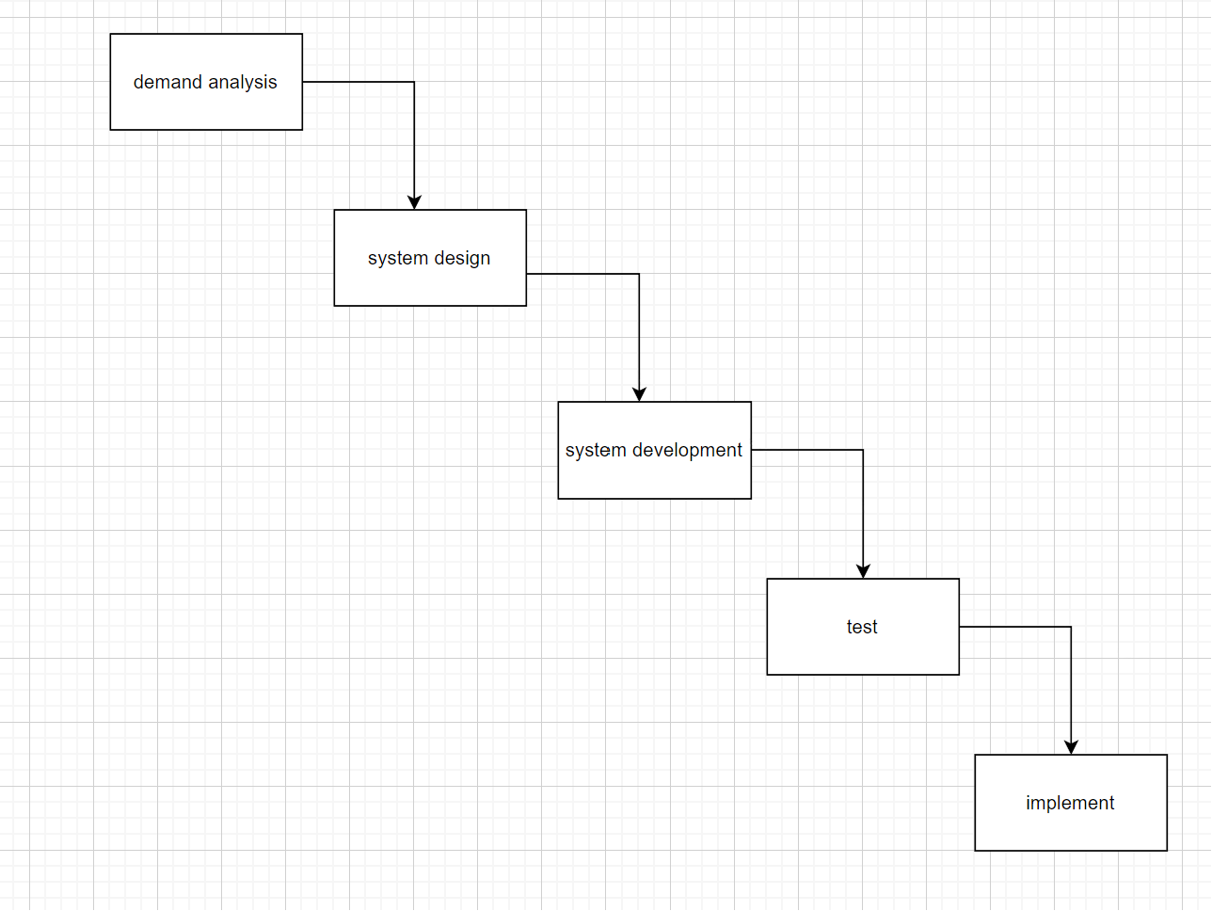

Project implementation process:

Risk issues: First, data migration issues: When implementing, it is necessary to ensure smooth migration of data to prevent data loss or inconsistency.

Secondly, user training and adoption issues: A new system may need to train users to ensure they can use it effectively without confusion or errors.

# Conclusion

In the analysis and implementation of the "Roads and Maritime NSW", I selected the following popular information technologies:

Cloud Computing: Cloud computing gives us the flexibility to meet the growing needs of our users. It helps improve the performance and usability of the website while reducing costs.

Blockchain technology: Blockchain technology provides us with highly secure data storage and transmission, ensuring the protection and compliance of user data. It also provides data traceability and increases data transparency.

Big Data and data Analytics: Big data and data visualization analytics help us better understand user needs and data trends. This helps improve service quality and decision support.

Suggestion:

First, the benefits of cloud computing should be continued to make sure the resilience and scalability of the system to adapt future demand growth.

Besides, exploring how blockchain technology can be applied more widely to improve the security and transparency of data and further strengthen user trust.

Furthermore, the invest in big data and data analytics should be continued to better understand user needs and data trends. Enhance data visualization to make decision making more intuitive.

Finally, pay regular attention to emerging information technology trends to ensure that the business portal remains competitive and adaptable to the changing technology environment.

# Reference

Khanna A, Jain S, Burgio A, Bolshev V & Panchenko V 2022, ‘Blockchain-Enabled Supply Chain platform for Indian Dairy Industry: Safety and Traceability’, foods, vol.11, no.7, 2716.

Merlec MM, Islam MM, Lee YK, In HP 2022, ‘A Consortium Blockchain-Based Secure and Trusted Electronic Portfolio Management Scheme.’, Sensors (Basel), vol.22, no.73, 1271.

Vavassori S, Soriano J, Fernández R 2017, ‘Enabling Large-Scale IoT-Based Services through Elastic Publish/Subscribe.’, Sensors (Basel), vol.17, no.9, 2148.

Vazquez P, Hirayama-Shoji K, Novik S, Krauss S & Rayner S 2022, ‘Globally Accessible Distributed Data Sharing (GADDS): a decentralized FAIR platform to facilitate data sharing in the life sciences.’, Bioinformatics, vol.38, no.15, 3812-3817.

Liu B, Zhang T & Hu W 2022，’Intelligent Traffic Flow Prediction and Analysis Based on Internet of Things and Big Data’, Computational intelligence and neuroscience.

Anwar, R. W., Qureshi, K. N., Nagmeldin, W., Abdelmaboud, A., Ghafoor, K. Z., Javed, I. T., & Crespi, N 2022, ‘Data Analytics, Self-Organization, and Security Provisioning for Smart Monitoring Systems’, Sensors (Basel, Switzerland), vol.22，no.19, 7201.